1)Tasks To Be Performed:
1. Deploy a Kubernetes cluster for 3 nodes
2. Create a NGINX deployment of 3 replicas

creating 3 instance ,there will be 3 node 1 master and 2 will be slave

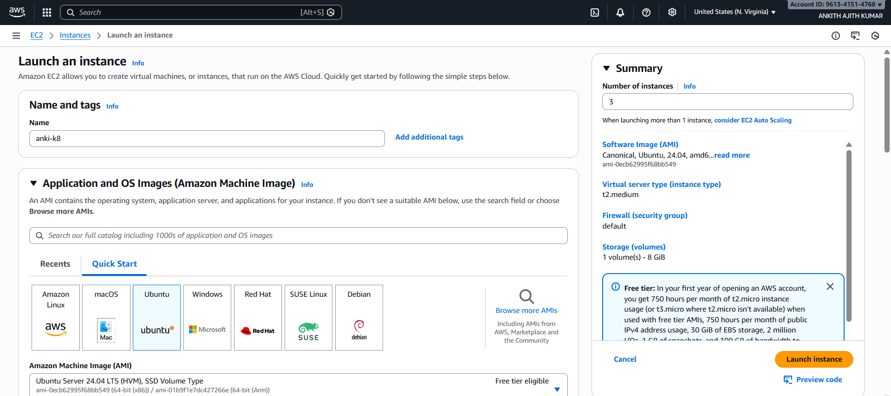
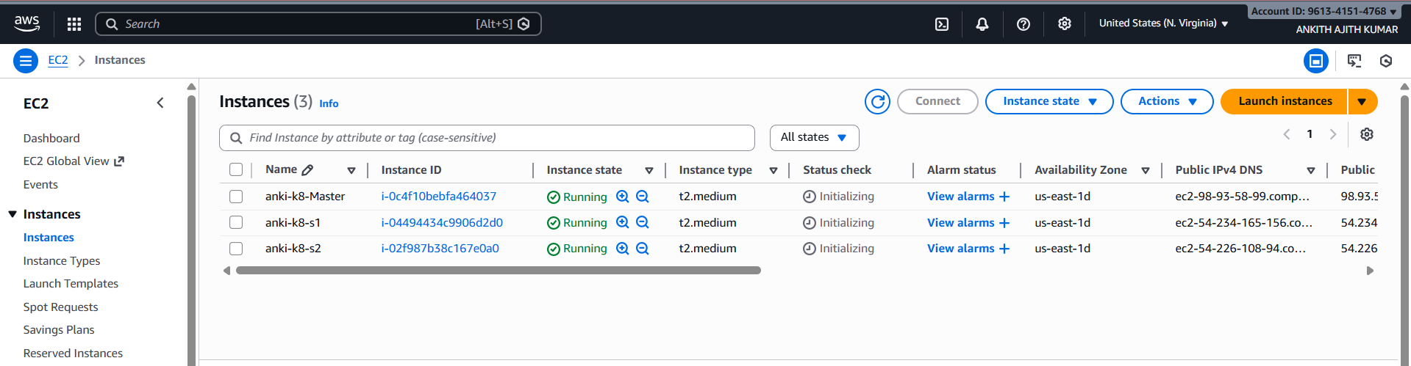
$ sudo apt update
$ sudo nano install.sh

#!/bin/bash
set -euxo pipefail

# Kuernetes Variable Declaration

KUBERNETES_VERSION="1.29.0-1.1"

# disable swap
sudo swapoff -a

# keeps the swaf off during reboot
(crontab -l 2>/dev/null; echo "@reboot /sbin/swapoff -a") | crontab - || true
sudo apt-get update -y

# Install CRI-O Runtime

OS="xUbuntu_22.04"

VERSION="1.28"

# Create the .conf file to load the modules at bootup
cat <<EOF | sudo tee /etc/modules-load.d/k8s.conf
overlay
br_netfilter
EOF

sudo modprobe overlay
sudo modprobe br_netfilter

# sysctl params required by setup, params persist across reboots
cat <<EOF | sudo tee /etc/sysctl.d/k8s.conf
net.bridge.bridge-nf-call-iptables = 1
net.bridge.bridge-nf-call-ip6tables = 1
net.ipv4.ip_forward = 1
EOF

# Apply sysctl params without reboot
sudo sysctl --system

cat <<EOF | sudo tee /etc/apt/sources.list.d/devel:kubic:libcontainers:stable.list
deb https://download.opensuse.org/repositories/devel:/kubic:/libcontainers:/stable/$OS/ /
EOF
cat <<EOF | sudo tee /etc/apt/sources.list.d/devel:kubic:libcontainers:stable:cri-o:$VERSION.list
deb http://download.opensuse.org/repositories/devel:/kubic:/libcontainers:/stable:/cri-o:/$VERSION/$OS/ /
EOF

curl -L https://download.opensuse.org/repositories/devel:kubic:libcontainers:stable:cri-o:$VERSION/$OS/Release.key | sudo apt-key --keyring /etc/apt/trusted.gpg.d/libcontainers.gpg add -
curl -L https://download.opensuse.org/repositories/devel:/kubic:/libcontainers:/stable/$OS/Release.key | sudo apt-key --keyring /etc/apt/trusted.gpg.d/libcontainers.gpg add -

sudo apt-get update
sudo apt-get install cri-o cri-o-runc -y

sudo systemctl daemon-reload
sudo systemctl enable crio --now

echo "CRI runtime installed susccessfully"

# Install kubelet, kubectl and Kubeadm

sudo apt-get update -y
sudo apt-get install -y apt-transport-https ca-certificates curl gpg

curl -fsSL https://pkgs.k8s.io/core:/stable:/v1.28/deb/Release.key | sudo gpg --dearmor -o /etc/apt/keyrings/kubernetes-1-28-apt-keyring.gpg
echo 'deb [signed-by=/etc/apt/keyrings/kubernetes-1-28-apt-keyring.gpg] https://pkgs.k8s.io/core:/stable:/v1.28/deb/ /' | sudo tee /etc/apt/sources.list.d/kubernetes-1.28.list

curl -fsSL https://pkgs.k8s.io/core:/stable:/v1.29/deb/Release.key | sudo gpg --dearmor -o /etc/apt/keyrings/kubernetes-1-29-apt-keyring.gpg
echo 'deb [signed-by=/etc/apt/keyrings/kubernetes-1-29-apt-keyring.gpg] https://pkgs.k8s.io/core:/stable:/v1.29/deb/ /' | sudo tee /etc/apt/sources.list.d/kubernetes-1.29.list

sudo apt-get update -y
sudo apt-get install -y kubelet="$KUBERNETES_VERSION" kubectl="$KUBERNETES_VERSION" kubeadm="$KUBERNETES_VERSION"
sudo apt-get update -y
sudo apt-mark hold kubelet kubeadm kubectl

sudo apt-get install -y jq

local_ip="$(ip --json addr show eth0 | jq -r '.[0].addr_info[] | select(.family == "inet") | .local')"
cat > /etc/default/kubelet << EOF
KUBELET_EXTRA_ARGS=--node-ip=$local_ip
EOF

$ bash install.sh
$ set -euxo pipefail

$PUBLIC_IP_ACCESS="true"
NODENAME=$(hostname -s)
POD_CIDR="192.168.0.0/16"

$sudo kubeadm config images pull

$if [[ "$PUBLIC_IP_ACCESS" == "false" ]]; then

MASTER_PRIVATE_IP=$(ip addr show eth0 | awk '/inet / {print $2}' | cut -d/ -f1)
sudo kubeadm init --apiserver-advertise-address="$MASTER_PRIVATE_IP" --apiserver-cert-extra-sans="$MASTER_PRIVATE_IP" --pod-network-cidr="$POD_CIDR" --node-name "$NODENAME" --ignore-preflight-errors Swap

elif [[ "$PUBLIC_IP_ACCESS" == "true" ]]; then

MASTER_PUBLIC_IP=$(curl ifconfig.me && echo "")
sudo kubeadm init --control-plane-endpoint="$MASTER_PUBLIC_IP" --apiserver-cert-extra-sans="$MASTER_PUBLIC_IP" --pod-network-cidr="$POD_CIDR" --node-name "$NODENAME" --ignore-preflight-errors Swap

else
echo "Error: MASTER_PUBLIC_IP has an invalid value: $PUBLIC_IP_ACCESS"
exit 1
fi

$mkdir -p "$HOME"/.kube
sudo cp -i /etc/kubernetes/admin.conf "$HOME"/.kube/config
sudo chown "$(id -u)":"$(id -g)" "$HOME"/.kube/config

$kubectl apply -f https://docs.projectcalico.org/manifests/calico.yaml

slave no s1,s1:

$sudo kubeadm reset pre-flight checks

go to master:

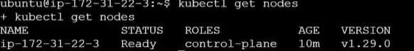
$sudo nano assign1.yaml

apiVersion: apps/v1
kind: Deployment
metadata:
name: assignment1-deployment
labels:
app: nginx
spec:
replicas: 3
selector:
matchLabels:
app: nginx
template:
metadata:
labels:
app: nginx
spec:
containers:
- name: nginx
image: nginx
ports:
- containerPort: 80

$kubectl apply -f assign1.yaml

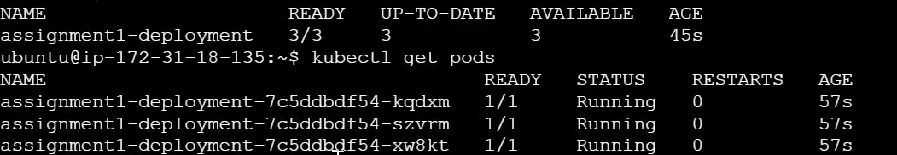

2)
1. Use the previous deployment
2. Create a service of type NodePort for NGINX deployment
3. Check the NodePort service on a browser to verify

$sudo nano assign2.yaml

apiVersion: v1
kind: Service
metadata:
name: my-service
spec:
type: NodePort
selector:
app: nginx
ports:
- port: 80

$kubectl apply -f assign2,yaml
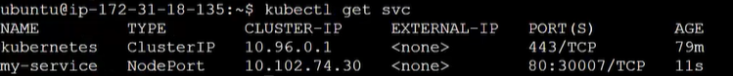
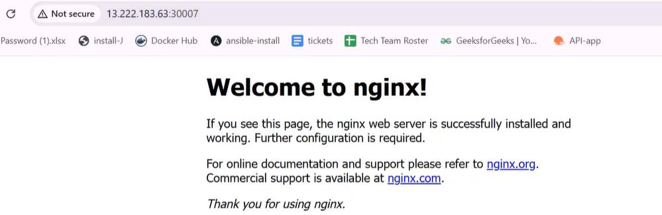

3)1. Use the previous deployment
2. Change the replicas to 5 for the deployment

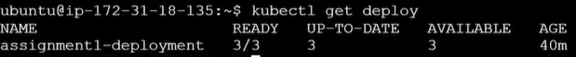
$kubectl edit deploy

changing replica :3 to replica :5
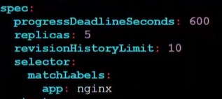

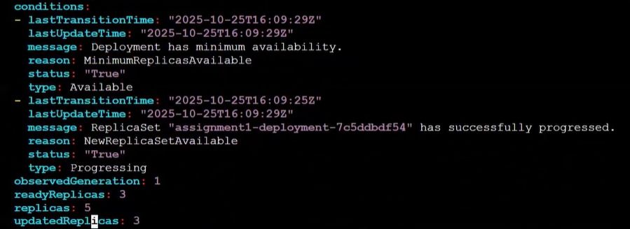

4)1. Use the previous deployment
2. Change the service type to ClusterIP

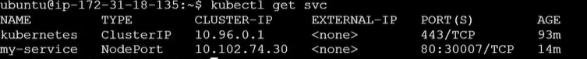
$kubectl edit svc
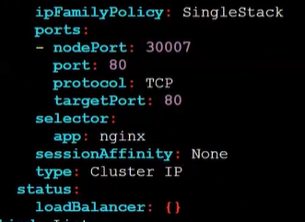

changed type from node port to cluster ip

5)1. Use the previous deployment
2. Deploy an NGINX deployment of 3 replicas
3. Create an NGINX service of type ClusterIP
4. Create an ingress service/ Apache to Apache service/ NGINX to NGINX
service

$kubectl apply -f https://raw.githubusercontent.com/kubernetes/ingress-nginx/controller-v1.9.4/deploy/static/provider/cloud/deploy.yaml

